Create a Login Page where we have 2 parts

Top: Register Page

part 1: image

part2 : form

* User Name
* Email
* Password
* button

success

Redirect to Login

Top: LoginPage

part 1: Image

part2 : Form

* Email
* Password
* button

1.Register page

<!DOCTYPE html>

<html lang="en">

<head>

    <meta charset="UTF-8">

    <meta name="viewport" content="width=device-width, initial-scale=1.0">

    <link rel="stylesheet" href="style.css">

    <title>Registration Page</title>

</head>

<body>

    <div class="container">

        <div class="register-page">

            <div class="content">

                <div class="img">

                    <img src="image.jpg" alt="Registration Image">

                </div>

                <div class="form-container">

                    <h2>Register</h2>

                    <form action="login.html">

                        <input type="text" name="username" placeholder="Username" required>

                        <input type="email" name="email" placeholder="Email" required>

                        <input type="password" name="password" placeholder="Password" required>

                        <button type="submit" href="login.html">Register</button>

                    </form>

                </div>

            </div>

        </div>

    </div>

</body>

</html>

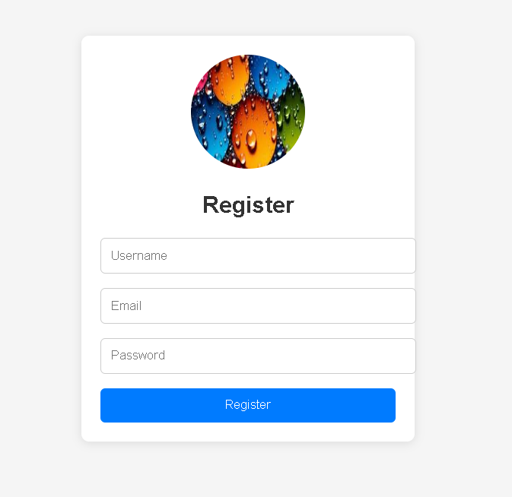

2.Login Page

<!DOCTYPE html>

<html lang="en">

<head>

    <meta charset="UTF-8">

    <meta name="viewport" content="width=device-width, initial-scale=1.0">

    <link rel="stylesheet" href="style.css">

    <title>Login Page</title>

</head>

<body>

    <div class="container">

        <div class="login-page">

            <div class="content">

                <div class="img">

                    <img src="image1.jpg" alt="Login Image">

                </div>

                <div class="form-container">

                    <h2>Login</h2>

                    <form>

                        <input type="email" name="email" placeholder="Email" required>

                        <input type="password" name="password" placeholder="Password" required>

                        <button type="submit">Login</button>

                    </form>

                </div>

            </div>

        </div>

    </div>

</body>

</html>

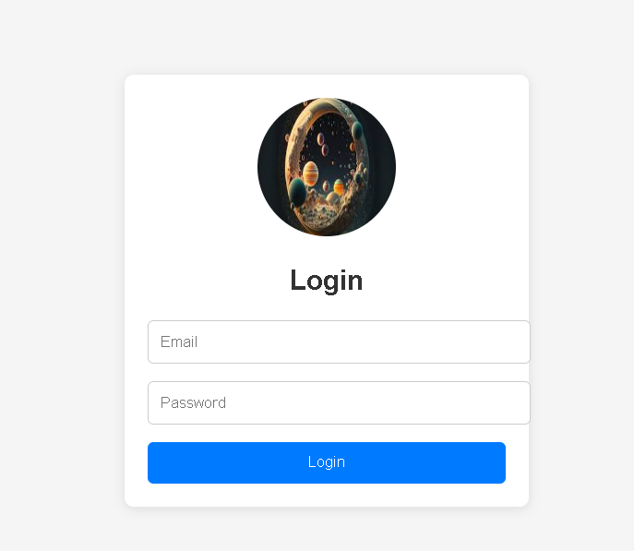

3.Style.css

body {

    font-family: Arial, sans-serif;

    margin: 0;

    padding: 0;

    background-color: #f5f5f5;

}

.container {

    display: flex;

    justify-content: center;

    align-items: center;

    min-height: 100vh;

}

.login-page {

    width: 350px;

    background-color: #fff;

    border-radius: 8px;

    box-shadow: 0 2px 10px rgba(0, 0, 0, 0.1);

}

.content {

    padding: 20px;

}

.img {

    text-align: center;

    margin-bottom: 20px;

}

img {

    width: 120px;

    height: 120px;

    border-radius: 50%;

}

.form-container {

    text-align: center;

}

h2 {

    margin-bottom: 20px;

    color: #333;

}

form {

    display: flex;

    flex-direction: column;

}

input[type="email"],

input[type="password"] {

    width: 100%;

    padding: 10px;

    margin-bottom: 15px;

    border: 1px solid #ccc;

    border-radius: 5px;

}

button {

    width: 100%;

    padding: 10px;

    background-color: #007bff;

    color: #fff;

    border: none;

    border-radius: 5px;

    cursor: pointer;

    transition: background-color 0.3s ease;

}

button:hover {

    background-color: #0056b3;

}

button:active {

    transform: scale(0.98);

}

body {

    font-family: Arial, sans-serif;

    margin: 0;

    padding: 0;

    background-color: #f5f5f5;

}

.container {

    display: flex;

    justify-content: center;

    align-items: center;

    min-height: 100vh;

}

.register-page {

    width: 350px;

    background-color: #fff;

    border-radius: 8px;

    box-shadow: 0 2px 10px rgba(0, 0, 0, 0.1);

}

.content {

    padding: 20px;

}

.img {

    text-align: center;

    margin-bottom: 20px;

}

img {

    width: 120px;

    height: 120px;

    border-radius: 50%;

}

.form-container {

    text-align: center;

}

h2 {

    margin-bottom: 20px;

    color: #333;

}

form {

    display: flex;

    flex-direction: column;

}

input[type="text"],

input[type="email"],

input[type="password"] {

    width: 100%;

    padding: 10px;

    margin-bottom: 15px;

    border: 1px solid #ccc;

    border-radius: 5px;

}

button {

    width: 100%;

    padding: 10px;

    background-color: #007bff;

    color: #fff;

    border: none;

    border-radius: 5px;

    cursor: pointer;

    transition: background-color 0.3s ease;

}

button:hover {

    background-color: #0056b3;

}

button:active {

    transform: scale(0.98);

}